

**A Fine Balance**

Speech given by Mark Carney,

Governor of the Bank of England

The Mansion House, London 20 June 2017

I am grateful to Clare Macallan and Iain de Weymarn for their assistance in preparing these remarks, and to David Bailey, James Benford, Paul Brione, Bob Gilhooly, Jeremy Martin, Eleonora Mavroeidi, Alex Michie, Anisha Tibrewal, Kenny Turnbull, Simon Whitaker and Tom Wise for background research and analysis.

# Introduction

My Lord Mayor, Chancellor, ladies and gentlemen.

In recent weeks, we have been reminded of fine balances: in decisions, in parliament, in life. The fine balance between hope and despair.1

Despair at the murder of Jo Cox. Hope in her remarkable life of service – an inspiration that lives on in her family, friends, colleagues and many admirers.

Despair at the terrorist attacks in Manchester, Borough Market and Finsbury Park. Despair at the tragedy of Grenfell Tower.

Hope in the heroism, resiliency and the community of the responses. Hope when we recognise our common humanity.

The best tribute this City and this Country can give to the memories of those lost is to renew our shared commitment – whatever our differences – to promote the common good.

This includes pursuing a Brexit, and building an economy, that works for all.

Since the prospect of Brexit emerged, financial markets, notably sterling, have marked down the UK’s economic prospects.2

Monetary policy cannot prevent the weaker real income growth likely to accompany the transition to new trading arrangements with the EU. But it can influence how this hit to incomes is distributed between job losses and price rises. And it can support households and businesses as they adjust to such profound change. Indeed, in such exceptional circumstances, the MPC is required to balance any trade-off between the speed with which it returns inflation sustainably to the target and the support that monetary policy provides to jobs and activity.

That is why last summer the Bank announced a series of monetary and macro-financial measures to support the economy during this transition. This stimulus is working. Credit is widely available, the cost of borrowing is near record lows, the economy has outperformed expectations, and unemployment has reached a 40 year low.

As spare capacity erodes, the trade-off that the MPC must balance lessens, and all else equal, its tolerance for above-target inflation falls. Different members of the MPC will understandably have different views about

1 ‘A Fine Balance’ by Rohinton Mistry.

2 The sterling ERI has fallen close to 20% from its November 2015 peak. Since then, UK-focused equity prices have fallen by over 2%. In contrast, broader equity price indices such as the FTSE 100 and S&P 500, which more heavily reflect global economic

considerations, are almost 20% and 40% higher respectively (in sterling terms). UK 10-year real government bond yields have fallen 115 basis points; by contrast 10-year real government bond yields in the US are down by around 25 basis points only.

the outlook and therefore on the potential timing of any Bank Rate increase. But all expect that any changes would be limited in scope and gradual in pace.

From my perspective, given the mixed signals on consumer spending and business investment, and given the still subdued domestic inflationary pressures, in particular anaemic wage growth, now is not yet the time to begin that adjustment. In the coming months, I would like to see the extent to which weaker consumption growth is offset by other components of demand, whether wages begin to firm, and more generally, how the economy reacts to the prospect of tighter financial conditions and the reality of Brexit negotiations.

During the negotiating period the economy will be importantly influenced by the *expectations* of households, firms and financial markets about the nature of both the transition and the longer term economic relationships with the EU and other countries.

Markets have already anticipated some of the adjustment. Depending on whether and when any transition arrangement can be agreed, firms on either side of the channel may soon need to activate contingency plans. Before long, we will all begin to find out the extent to which Brexit is a gentle stroll along a smooth path to a land of cake and consumption.

Whatever happens, monetary policy will be set to return inflation sustainably to target while supporting as best it can the necessary adjustments in the economy.

I would like to spend the rest of my time on another balance, or rather other imbalances, whose resolution will be an important determinant of our future prosperity.

# The Challenge of Global Imbalances

With many concerned that global trade is taking local jobs, protectionist sentiments are once again rising across the advanced world. Excessive trade and current account imbalances are now politically as well as economically unsustainable.

Perhaps because imbalances ultimately reflect savings and investment choices within a country, they are often described as morality tales with the virtues of Swabian housewives contrasted with the vices of the Anglo Saxon rakes.

In fact, trade imbalances are natural features of an open system and can be warranted by differences in demographics, levels of development and expected paths for income.3

3 Savings and investment imbalances will shift with changes in relative prices, including changes in prices of final goods and services, changes in nominal exchange rates, changes in relative production costs (including unit labour costs), and changes in the costs of trade. Lags and frictions will mean that different components will shift at varying speeds. This, in turn, can result in large adjustment costs not present in economic models, which can make a laissez faire approach risky.

For example, emerging market economies with young populations and bright prospects should be expected to run large deficits, as Canada did for decades at the turn of the last century.4 In contrast, rapidly ageing countries should run large surpluses, as confirmed by Bank research (**Chart 1**). 5

# Chart 1: Demographics and current accounts

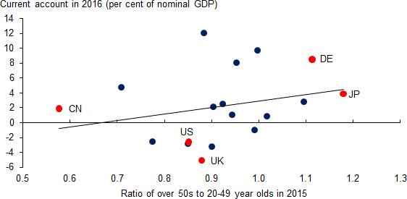

Sources: April 2017 WEO and UN.

Notes: The countries labelled in the chart are China (CN), Germany (DE), Japan (JP), the United Kingdom (UK) and the United States of America (US). The data point for the 2016 current account for the UK has been adjusted to take account of the likely effect of revisions announced by the ONS, to be incorporated in Blue Book 2017, and erratic movements in trade in non-monetary gold. The adjustment is based on the average revision in 2011 and 2012 and is applied to the 2016 data published in the 2016 Q4 Balance of Payments release.

These are “good imbalances,” and we need global trade and financial systems that encourage and facilitate them.

There are also “bad imbalances” caused by domestic distortions (for example, in the financial or social welfare systems that affect savings and investment decisions); global deficiencies (such as inadequate global safety nets which encourage reserve accumulation); or mercantilist and protectionist policies (which manage trade).

And that is part of what is occurring today, with Japan, Germany and China running excess surpluses relative to fundamentals; and the US and the UK running excess deficits (**Chart 2**). And although the euro- area excess surplus is relatively modest relative to its GDP, in absolute terms it is at least as important as those of Japan or China (**Chart 3**).6 So while the distortions are few in number, those that exist are large in scale and systemic in importance.

4 Canadian deficits averaged 8% of GDP in the thirty years before World War I. ‘Canada in a multi-polar world’, speech by Mark Carney, 16 May 2011, available at [http://www.bankofcanada.ca/2011/05/canada-in-a-multi-polar-world.](http://www.bankofcanada.ca/2011/05/canada-in-a-multi-polar-world/)

5 See Lisack, N., Sajedi, R. and Thwaites, G. ‘Demographic trends and the real interest rate’, Bank of England Staff Working Paper forthcoming.

6 Small economies hosting large financial centres like Singapore and Switzerland are special cases for which it is difficult to estimate

‘norms’.

# Chart 2: Actual current account balances and IMF estimates of fundamental balances

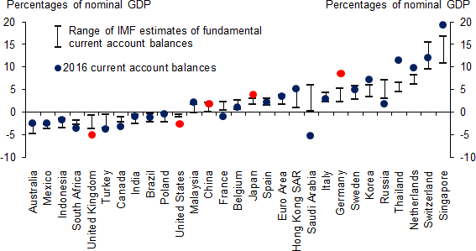

Sources: IMF July 2016 External Sector Report, WEO April 2017 and Bank calculations.

Notes: The data point for the 2016 current account for the UK has been adjusted; see notes to Chart 1 for more details.

# Chart 3: Excess current account balances

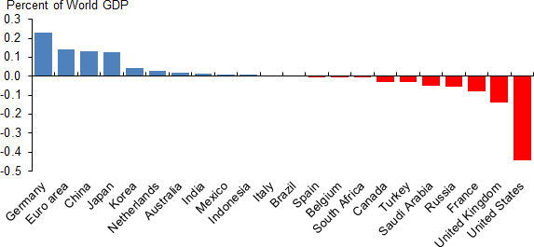

Sources: IMF July 2016 External Sector Report and WEO April 2017.

Notes: Excess is calculated as the difference between the actual current account balance in 2016 and the mid-point of the range of IMF estimates of the fundamental balances, shown in Chart 2. The data for the 2016 current account for the UK has been adjusted; see notes to Chart 1 for more details.

Such global imbalances matter for at least three reasons.

First, from the Lawson boom to the Tequila and Global Financial Crises, a common lesson is that large current account deficits are one of the most trenchant early warning signs of financial instability.7 This is

7 Blanchard, O. and Milesi-Ferretti, G.M. (2011), ‘(Why) Should Current Account Balances Be Reduced?’, IMF Staff Discussion Note, No. 11/03.

especially true when deficits are accompanied by rapidly growing domestic credit.8 It is dangerous to rely entirely on the discipline of the domestic financial system. In each case, the eventual large private losses weighed on public balance sheets and growth for years.9

Second, when imbalances reflect unfair competitive advantage – either through managed trade or managed exchange rates – they can lead to protectionist backlashes that leave everyone worse off.

And third, in the current environment of synchronised weakness and limited policy space, it is not hard to imagine this low inflation / low wage / low growth trap being sealed as it was in the 1930s.

In this environment, the UK is running a historically large current account deficit. On the positive side, the deficit is funded in domestic currency and financial reforms have increased the resilience of the UK system, thereby making larger imbalances more sustainable. But the UK’s deficit has also been associated with markedly weak investment and latterly with rapid consumer credit growth. This is not an imbalance that is, as yet, funding its eventual resolution.

Moreover, despite the large depreciation around the referendum, the extent to which the UK’s deficit has moved closer to sustainability remains an open question, one whose answer depends crucially on the outcome of the Brexit negotiations.

Most fundamentally, the UK relies on the kindness of strangers at a time when risks to trade, investment, and financial fragmentation have increased.

# Potential Solutions

The world economy has been here before. In the 1930s monetary policy was exhausted and fiscal policy was in abeyance. The trap was sealed by a wave of protectionist measures originating in the US and spreading to Europe. As current and capital accounts closed, stagnation ensued.

What should be done to prevent history from rhyming?

In the simple world of the economist, the prescription is straightforward. Deficit countries should loosen monetary policy and tighten fiscal policy. Surplus countries should do the reverse.10 If only the G20 would roll up its sleeves, it could easily solve this economic Sudoku.11

But such cures are prescribed in the abstract where policy space is unconstrained – a situation far removed from current realities.

8 Caballero, J. (2014) ‘Do surges in international capital inflows influence the likelihood of banking crises?’ Economic Journal.

9 For example, the IMF estimate that the output cost in Mexico following the Tequila Crisis of 1994-96 was around 14% (Laeven, L. and

Valencia, F. (2012), ‘Systemic banking crises database: an update’, IMF working paper). For the global financial crisis, the cumulative loss of global output, when compared to its pre-crisis trend, is of the order of 25% of global output, while for the Lawson boom it is close to 10% of UK output.

10 More recently, attention has been paid to the need to maintain appropriate macroprudential policies as well as monetary and fiscal. See, for example, the IMF policy paper (2011) ‘Macroprudential Policy: An Organizing Framework’.

11 See speech by Mervyn King at the University of Exeter, 19 January 2010, available at [http://www.bankofengland.co.uk/archive/Documents/historicpubs/speeches/2010/speech419.pdf.](http://www.bankofengland.co.uk/archive/Documents/historicpubs/speeches/2010/speech419.pdf)

Monetary policy is still challenged by the lingering risks of a global liquidity trap, with a very low global equilibrium interest rate, r* – the interest rate central banks must deliver in order to balance demand with supply and so achieve stable inflation. Colleagues at the Bank estimate that secular forces – which include demographics, the lower relative price of capital, higher costs of financial intermediation, and inequality – have reduced global long-term interest rates by around 4 percentage points since the 1980s.12 In addition, cyclical forces since the crisis including high policy uncertainty and hedging of disaster risk are exerting further drags on private investment, not least through reinforcing the option value of waiting.13

Fiscal space is limited in the wake of the financial crisis. And the space that exists is often unevenly distributed – with the euro area providing the classic example.14 Given the heavy burden on European monetary policy, the still sizable amount of slack in the euro area, low European borrowing costs and *aggregate* fiscal space, it is difficult to avoid the conclusion that if the euro area were a country, fiscal policy would play a greater role in promoting internal and external balance and the world would be better off accordingly.

Moreover, as in the 1930s, theoretical remedies are generally falling foul of the real world reluctance of surplus countries to share the adjustment burden. Unlike deficits, surpluses can be run for a very long time as they are not hostage to changing preferences of investors and are only gradually affected by their domestic impact.15

For these and other reasons, work at the IMF and the Bank suggests that changing the macro policy mix in systemic countries would at best reduce only about one third of their excess imbalances (**Chart 4**).16

Why not just leave the rest to exchange rates? This might prove risky not just because exchange rates tend to move slowly then significantly, but also because IMF estimates of the required changes are greater than have occurred in any year since the collapse of Bretton Woods.17

12 See Rachel, L and Smith, T (2015), ‘Secular drivers of the global real interest rate’, Bank of England Working Paper No. 571.

13 As Ben Broadbent has noted, as uncertainty rises, the option value of waiting also rises – with a simple model suggesting it can add around 10pp to the hurdle rate that firms need to meet. See ‘Uncertain times’, speech by Ben Broadbent at the Wall Street Journal,

5 October 2016, available at [http://www.bankofengland.co.uk/publications/Documents/speeches/2016/speech929.pdf.](http://www.bankofengland.co.uk/publications/Documents/speeches/2016/speech929.pdf)

14 For example, consider the following comparison between the euro area and the UK. In the euro area, the private sector continues to generate surplus savings of 5% of GDP. Those must be recycled effectively to generate an expansion. The UK no longer faces that

challenge. Its private sector is in balance. The euro-area unemployment rate of just over 9% is twice that in the UK. Gross general government debt in the euro area is roughly the same as in the UK and below the average of advanced economies. The weighted average yield on 10-year euro-area sovereign debt is similar to that in the UK, at close to 1%. And yet, the euro area’s fiscal deficit is half that in the UK. Its structural deficit, according to the IMF, is around one third as large. It is difficult to avoid the conclusion that, if the euro zone were a country, fiscal policy would be substantially more supportive.

15 See Blanchard, O. and Milesi-Ferretti, G.M. (2011), ibid.

16 The macro policies included in the IMF’s analysis are fiscal, credit, foreign exchange reserves, the social safety net (proxied by spending on health) and capital controls. For Germany, for example, the IMF estimate that only 0.6pp of the assessed 4.8% excess

current account surplus is due to an overly tight domestic policy mix relative to other countries and a further 0.8pp is accounted for by the policy mix being too loose elsewhere. In China, the IMF analysis indicates a tightening of domestic policies is needed, which would increase the current account surplus rather than reduce it. For more detail, see the IMF’s 2016 External Sector Report, available at [https://www.imf.org/external/np/pp/eng/2016/072716.pdf.](https://www.imf.org/external/np/pp/eng/2016/072716.pdf)

17 See the IMF 2016 External Sector Report, available at [https://www.imf.org/external/np/pp/eng/2016/072716.pdf.](https://www.imf.org/external/np/pp/eng/2016/072716.pdf)

# Chart 4: Excess current account balances and policy gaps in 2015

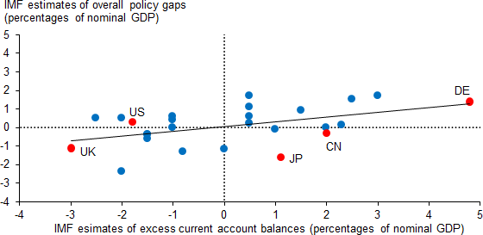

Source: IMF July 2016 External Sector Report.

Notes: The countries labelled in the chart are China (CN), Germany (DE), Japan (JP), the United Kingdom (UK) and the United States of America (US). See the notes to Chart 2 for how excess current account balances are calculated.

And since all countries cannot become more competitive at the same time – it is a relative concept – there is no avoiding it: higher global growth will require comprehensive measures to boost productivity and with it, real wages and demand. This means domestic policies to spur innovation, technology adoption, and the reallocation of resources.

Particularly important will be measures to re-start the stalled ‘diffusion machine’.18 While the most productive companies have continued to innovate, others have become slower at adopting those innovations.

Speeding up the rate of take-up of new inventions and processes – for example through greater product market competition or challenges to management to benchmark against best practice19 – would provide a significant boost to overall productivity growth.

And higher growth requires a new approach to trade policy. Consider that Bank of England research estimates that up to one half of the post-crisis productivity slowdown could be related to the deceleration in global trade growth.20

It will not be enough for the G20 to “resist protectionism.” The G20 now needs to make “trade work for all.” That includes using e-commerce platforms to promote free trade for SMEs across the G20,21 and it requires an urgent and critical examination of trade in services.

18 See [https://www.oecd.org/eco/growth/OECD-2015-The-future-of-productivity-book.pdf.](https://www.oecd.org/eco/growth/OECD-2015-The-future-of-productivity-book.pdf)

19 See the report written by the Productivity Leadership Group, chaired by Sir Charlie Mayfield, (2016), ‘How good is your business really? Raising our ambitions for business performance’, available at: [https://howgoodisyourbusinessreally.co.uk/.](https://howgoodisyourbusinessreally.co.uk/)

20 See ‘The world trade slowdown redux’, Bank Underground blogpost, available at [https://bankunderground.co.uk/2016/12/12/the-](https://bankunderground.co.uk/2016/12/12/the-world-trade-slowdown-redux/)

[world-trade-slowdown-redux/](https://bankunderground.co.uk/2016/12/12/the-world-trade-slowdown-redux/) and Frenkel, J. and Rose, A. (2000) ‘Estimating the Effect of Currency Unions on Trade and Output’, NBER working paper No. 7857.

21 As noted in ‘The Spectre of Monetarism’, speech given by Mark Carney, Roscoe Lecture, Liverpool John Moores University, 5 December 2016, available at [http://www.bankofengland.co.uk/publications/Pages/speeches/2016/946.aspx.](http://www.bankofengland.co.uk/publications/Pages/speeches/2016/946.aspx)

In this context, Brexit in general and financial services in particular will be key tests of the world’s capacity to build a path to stronger, more sustainable growth.

# Levelling Down or Up: Managed Trade or Free Trade in Services?

One cause of global imbalances is the uneven playing field between trade in goods and services, with barriers to services trade currently up to three times higher.22

Most of the world’s major surplus countries, like Germany and China, are net exporters of goods and benefit from this asymmetry. Conversely countries with a comparative advantage in services, like the US and UK, are more likely to run current account deficits (**Charts 5 and 6**).

# Chart 5: Correlation between current account balances and comparative advantage in services

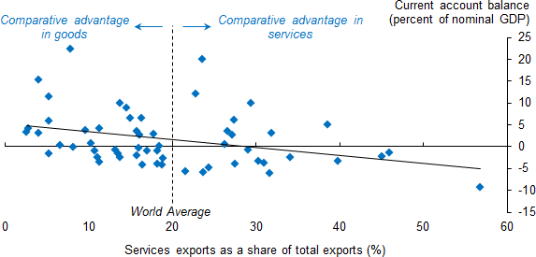

Sources: Barattieri, A. (2014), ‘Comparative advantage, service trade, and global imbalances’, *Journal of International Economics*, Vol. 92, Issue 1, UNCTAD and WEO April 2017.

Notes: The chart shows average current accounts for the 57 largest economies over the decade 2006-2015 against each country’s share of services in total exports (the higher this share the more comparative advantage in services that country has).

22 Miroudot, S., Sauvage, J. and Shepherd, B. (2013), ‘Measuring the cost of international trade in services’, *World Trade Review*, Vol. 12, Issue 4, pp 719-35.

# Chart 6: Goods and services components of current account balances

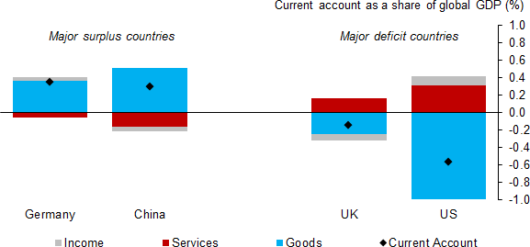

Source: WEO April 2017. Notes: Averages for 2011-2015.

The G20 faces a choice – between levelling down by putting more restrictions on goods trade, or levelling up by liberalising trade in services.

Evidence from within countries suggests that there may be substantial scope to increase trade in services if barriers are removed. For example, in Canada – one of the few countries to track trade flows within its borders – services account for around 50% of all inter-provincial trade compared with only 25% of Canada’s international exports. If Canada were able to replicate the pattern of trade within its borders with other countries then services exports would triple.

Reducing restrictions on services trade to the same extent as those on goods have been over the past couple of decades could reduce the excess deficits of the US by one third and the UK by one half.23

Services liberalisation is also a more efficient form of rebalancing because services industries tend to have higher domestic value added, and jobs, than manufactured goods. The lower import content of services compared with goods means smaller changes are needed to address current account imbalances.24 For example, a £10 billion increase in UK financial services exports would reduce the UK’s trade deficit by £9 billion, whereas the same increase in exports of autos would contribute £5½ billion.

Of course, liberalising services is not straightforward, as barriers are typically not tariffs but ‘behind the border’ differences in regulatory standards and trading conditions. This is where global standards and regulatory cooperation should help.

23 Roughly equal to 15%. These calculations are based on the estimated effects of reducing services trade restrictions on services exports reported in Nordås, H.K. and Rouzet, D (2016), ‘The impact of services trade restrictiveness on trade flows’, *The World Economy*, and the estimated mapping between services trade restrictions and services trade costs reported in Miroudot, S. and Shepherd, B (2016) ibid*.*

24 In sterling terms. In percentage terms, the changes are larger for services reflecting the fact that they start from a smaller base.

Arguably the greatest possibilities are in financial services given the major progress in financial reform. Indeed, financial services could serve as a template for broader services trade liberalisation. And with Brexit, we have the coincidence of necessity and opportunity.

Since the crisis the G20 has agreed a series of new international minimum standards to secure the resilience of the banking sector, transform shadow-banking into resilient market-based finance, make derivatives markets safer and end too-big-to fail. Implementation is now being regularly assessed and transparently reported by the FSB and IMF. The playing field for cross-border activities is being levelled.

At the same time, supervisory cooperation has intensified. Information is now readily shared through supervisory colleges. And regular crisis management groups for systemic firms are building confidence in how authorities will behave when things go wrong.

In short, platforms are being created for deference to each other’s approaches when they achieve similar outcomes. With robust standards consistently applied, wholesale financial services could be brought more fully into bilateral trade agreements, keeping the global financial system open and resilient, and supporting greater trade, investment and innovation.

Let me use a specific example of CCPs in London – although my points apply more generally and reciprocally to all critical cross-border financial market infrastructure in the UK and Europe.

Prior to the crisis, derivative transactions created a complex, opaque – and dangerous – web of exposures that helped turn a shock into a panic.

With the G20’s encouragement, CCPs are now helping to untangle this web and build resilience. Moreover, by netting exposures across counterparties, currencies and products; CCPs are supporting more liquid markets and are lowering costs to end users. That means more resilient financing and better risk management for business and households.

The UK houses some of the world’s largest CCPs. For example, LCH in London clears swaps in 18 currencies for firms in 55 jurisdictions, handling over 90% of cleared interest rate swaps globally and 98% of all cleared swaps in euros. All currencies, products and counterparties benefit from the resulting economies of scale and scope.

Fragmentation of such global markets by jurisdiction or currency would reduce the benefits of central clearing. EU27 firms account for only a quarter of global activity in cleared euro interest rate swaps, and about 14% of total interest rate swaps in all currencies cleared by LCH. Any development which prevented EU27 firms from continuing to clear trades in the UK would split liquidity between a less liquid onshore market for EU firms and a more liquid offshore market for everyone else.

The potential for higher costs is not theoretical. In Japan, for example, where the clearing of yen- denominated swaps by certain Japanese firms must take place onshore, the difference in price between the onshore and offshore markets has generally been in the range of 1-3 basis points.

Such seemingly small price differences translate into significant costs for users given the scale of activity in these markets. Industry estimates suggest that a single basis point increase in the cost resulting from

splitting clearing of interest rate swaps could cost EU firms €22bn per year across all of their business. Those costs would ultimately be passed on to European households and businesses.

Moreover if the large stock of existing trades of EU firms – tens of trillions of euros in size – was trapped at a CCP which was no longer recognised by the European Commission, those EU firms would face capital charges as much as ten times higher than today unless and until they could move them.25

Fragmenting liquidity would drive up costs somewhat in the remaining market as well. On current volumes, almost 90% of swaps are traded by non-EU firms and could remain in the main UK-based liquidity pool.

Given the size of this market, the impacts could be expected to be much smaller, although not insignificant.

Fragmentation is in no one’s economic interest. Nor is it necessary for financial stability. Indeed it can damage it. Fragmenting clearing would lead to smaller liquidity pools in CCPs, reducing the ability to diversify risks and diminishing resilience. And higher costs would reduce the incentives to hedge risks, increasing the amount of risk that the real economy would have to bear.

The Bank of England fully recognises European concerns. I know because I shared similar ones as Governor of the Bank of Canada. These were addressed then through common standards and cooperative supervisory oversight, allowing C$ clearing to move to a more efficient and resilient hub in London. The Bank of England also must concern itself with the resilience of CCPs in other European and non-European jurisdictions that are used by firms that we supervise. These CCPs must be subject to robust regulatory standards and deep reciprocal supervisory cooperation.

To address such issues, we can and should build on current models to develop a new form of regulatory and supervisory cooperation.

The European Commission’s proposals announced last week recognise the importance of effective cooperation arrangements between the relevant EU authorities and their overseas counterparts. They include potential provisions for deference to the rules to which a CCP is subject in its home jurisdiction in line with the intent of the G20.26

The Bank welcomes this. The Commission’s proposals, driven in part by Brexit, address an increasingly important and more general issue in the regulation of the international financial system.

25 Requiring up to another €5bn of capital.

26 See, for example, the G20 Leaders’ communique, Brisbane Summit, 16 November 2014, available at [http://www.g20australia.org/official_resources/g20_leaders_communique_brisbane_summit_november_2014.html.](http://www.g20australia.org/official_resources/g20_leaders_communique_brisbane_summit_november_2014.html)

Elements of these proposals could therefore provide a foundation on which to build robust cross-border arrangements for the supervision of CCPs. This should be based on deep cooperation between jurisdictions and authorities who defer to each other’s regimes where they meet international standards and deliver similar outcomes.

Coming to an innovative, cooperative and reciprocal agreement on central clearing would promote competitive financing in the euro area and maintain the resilience of the UK and global financial systems.

More fundamentally, it would be an early milestone in the broader rebalancing of the UK, European and global economies. And it would produce far superior outcomes to other elements of the Commission’s proposals, which would fragment global clearing activity and raise costs and risks.

# Conclusion

My Lord Mayor, this building, with all its majesty and history and this topic, central clearing of derivatives; could not appear farther from the concerns of people in this country.

But they are much more closely related than they appear.

A decade of radical financial reform was not an end in itself, but rather a means to serve households and businesses better. We must ensure that the real economy reaps its full benefits, including through freer trade in services and more resilient financing of the investment needed to boost wages of workers in all industries across the UK.

One million people across this country work in financial services. The industry contributes 7% of output and pays taxes that cover almost two thirds of the cost of the NHS. At a time when the UK is running a 5% current account deficit, financial services runs a 1.5% trade surplus with Europe alone. The entire service sector runs a 5% surplus with the world and employs 85% of UK workers.

We could take these realities for granted. And it would be all too easy to give into protectionism. But as we learned in the 1930s, that road leads neither to equity nor prosperity. Raising barriers to trade disproportionately hurts the least well off through higher prices and fewer opportunities.27

27 Fajgelbaum, P.D. and Khandelwal, A.K. (2016), ‘Measuring the Unequal Gains from Trade’, *Quarterly Journal of Economics*, Vol. 131, Issue 3, shows that past episodes of trade liberalisation have disproportionately benefited poor households, in every country, through reductions in consumer prices and increases in product variety.

Escaping the low inflation / low wage / low growth trap requires more than a textbook rebalancing of macro policies across the major regions. It demands comprehensive structural reforms and a new approach to trade policy. Such changes could more than make up for the dramatic fall in the real incomes that UK households have experienced in the decade since the crisis.28

The Brexit negotiations will be the test. May the hundreds in this room pass it by working towards innovative, cooperative and responsible solutions to the benefit of the tens of millions outside.

28 As my colleague Andy Haldane noted in his speech ‘Productivity Puzzles’(available at [http://www.bankofengland.co.uk/publications/Documents/speeches/2017/speech968.pdf)](http://www.bankofengland.co.uk/publications/Documents/speeches/2017/speech968.pdf), if productivity growth in the second, third and fourth quartiles of the distribution of UK firms’ productivity could be boosted to match the productivity of the quartile above, then arithmetically that would deliver a boost to aggregate UK productivity of around 13%. In the longer run, that increase in productivity would be expected to flow through fully into real wages. By contrast, the peak to trough fall in real wages following the crisis was in the region of 10%.